Controls: Navigate the menus with the onscreen buttons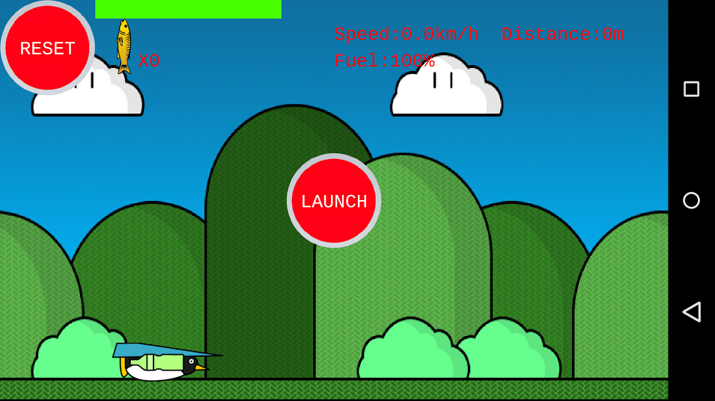

Tilt the phone to move the penguin up and down

Objective: Collect fuel and fish to travel to most distance possible

Pickup items: Fish-Gives fuel and increases fish count

Energy-Gives fuel

Super Jetpack-gives super speed